数学与应用数学2018级2班（女生）

20183648  董妍 | 20183650  梁静妮 | 20183651  李可心 | 20183652  刘佳 | 20183653  李笑盈
20183654  李颖 | 20183655  鲁海玥 | 20183656  马显瑛 | 20183657  王渺 | 20183658  徐薇
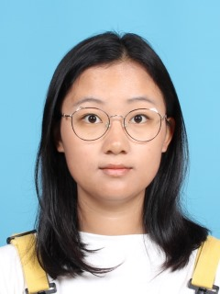
20183659  雍宇航 | 20183660  张长莲 | 20183661  赵蕊

数学与应用数学2018级2班（男生）

20183662  安首鹏 | 20183663  安智韬 | 20183664  包嘉祥 | 20183665  方幅瑾 | 20183666  宫钰
 |  |  |  | 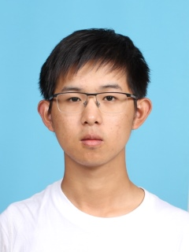
20183667  郭远达 | 20183668  韩军 | 20183669  凌锐衡 | 20183670  李沛 | 20183671  刘浩泽
20183672  刘锦霖 | 20183673  罗锦浩 | 20183674  田立 | 20183675  王珠源 | 20183676  邢洺瑞
20183677  徐仕琪 | 20183679  杨旭 | 20183680  张健全 | 20183681  张子轩 | 20183682  张宗乐

